**Project Design Phase-II**

**Technology Stack (Architecture & Stack)**

|  |  |
| --- | --- |
| Date | 17 October 2022 |
| Team ID | PNT2022TNID26521 |
| Project Name | Project - IoT Based Smart Crop Protection System for Agriculture |
| Maximum Marks | 4 Marks |

**Technical Architecture:**

The architectural diagram of the model is as below and the Technology used is shown in table1 & table 2

**Reference:** https://smartinternz.com/guided-project/iot-based-smart-agriculture

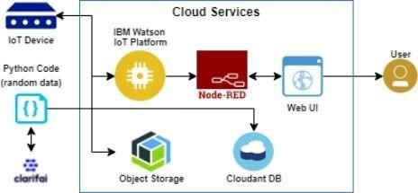

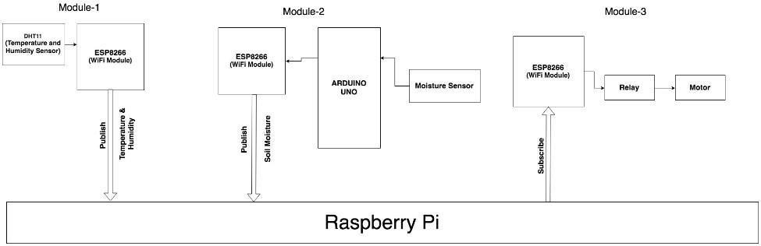

**FIG. 1. BLOCK DIAGRAM**

**Table-1: Components & Technologies:**

|  |  |  |  |
| --- | --- | --- | --- |
| **S.No** | **Component** | **Description** | **Technology** |
| 1. | User Interface | How user interacts with application e.g., Mobile Application | HTML, CSS, JavaScript / Angular JS / Node Red. |
| 2. | Application Logic-1 | Logic for a process in the application | Java / Python |
| 3. | Application Logic-2 | Logic for a process in the application | IBM Watson STT service |
| 4. | Application Logic-3 | Logic for a process in the application | IBM Watson Assistant |
| 5. | Database | Data Type, Configurations etc. | MySQL, NoSQL, etc. |
| 6. | Cloud Database | Database Service on Cloud | IBM DB2. |
| 7. | File Storage | File storage requirements | IBM Block Storage or Other Storage Service or Local Filesystem |
| 8. | External API-1 | Purpose of External API used in the application | IBM Weather API, etc. |
| 9. | IoT Model | Purpose of IoT Model is for integrating the sensors with a user interface. | IBM IoT Platform |
| 10. | Infrastructure (Server / Cloud) | Application Deployment on Local System / Cloud Local Server Configuration:  Cloud Server Configuration : | Local, Cloud Foundry, Kubernetes, etc. |

**References:**  [**https://smartinternz.com/guided-project/iot-based-smart-agriculture**](https://smartinternz.com/guided-project/iot-based-smart-agriculture)

[**https://www.computerweekly.com/news/252504285/How-IoT-and-machine-learning-are-automating-agriculture**](https://www.computerweekly.com/news/252504285/How-IoT-and-machine-learning-are-automating-agriculture)

[**https://components.omron.com/us-en/solutions/iot**](https://components.omron.com/us-en/solutions/iot)